**Online Vs Offline Education**

A few years ago, online education wasn’t quite familiar. It has begun to gain increasing popularity since the world pandemic (2019) since it was the only means of available education then.

Several Aspects related to online education would be discussed.

**1-Study time in hours and grades:**

On performing linear regression on a dataset sample describing the observations for several students’ study hours and their grades (out of 100) the following graphical relation was obtained in the case of traditional education:

Grades

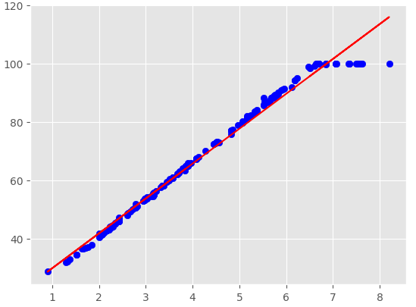

Study Time in hours

From the graph we can deduce that there is a strong direct relationship between students’ grades and study times is hard (since the slope is quite large).

On performing the same linear regression on a dataset sample describing the observations for several students’ study hours and their grades (out of 100) the following graphical relation was obtained in the case of online education:

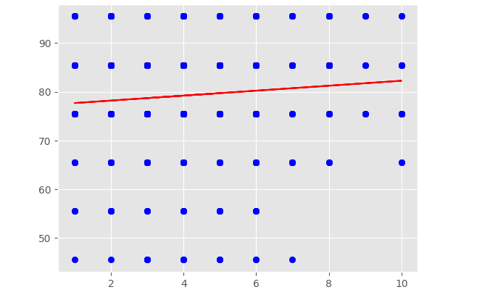

Grades

Study Time in hours

From the graph we can deduce that there is a weak direct relationship between students’ grades and study times is hard (since the slope is quite small) (grades no longer depend on study time in hours).

Conclusion:

The dependency of final grades on the study time in hours decreases on resorting to online education.

**2-Grades Average:**

In the case of the Traditional education sample, the average grade was found to be 75.89 with S.D of 20.954

And the Mode grade range (81-91)

With frequency histogram plot (using 6-bins):

Freq

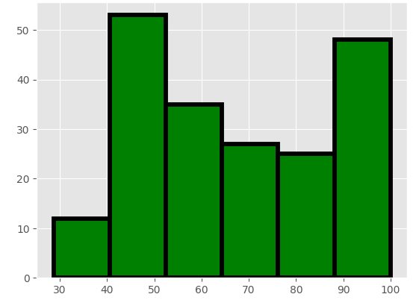

Grades

In the case of the Online education sample, the average grade was found to be 79.5, and the S.D. of

11.63

And the Mode grade range (81-91)

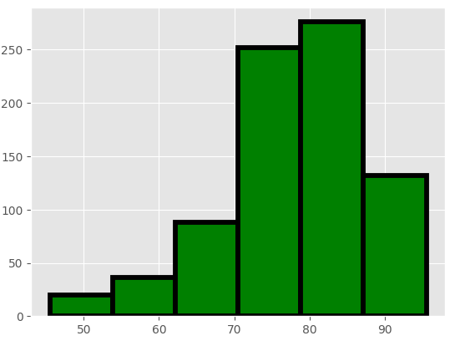With frequency histogram plot (using 6-bins):

Freq

Grades

Conclusion:

the mean of grades in the case of online education is higher with data more clustered around the mean.

On carrying out a hypothesis test on online education data where:

NULL Hypothesis: **µ** = 75.89385 (mean of traditional education grades)

Alternative Hypothesis: **µ** >75.89385 (mean of traditional education grades)

(A one-tail test is used with a confidence of 95%)

The Null hypothesis was rejected indicating that the mean of grades in the case of online education is not equal to the mean of grades in the case of online education.

We accept the first hypothesis (the mean of grades is larger in the case of online education) which agrees with our Conclusion.

**3-Study Time:**

In the case of Traditional education, the mean of study hours was found to be: 4.638 hours.

A confidence interval with a confidence level of 95% was calculated which is

(3.81539461, 4.30170539).

In the case of Traditional education, the mean of study hours was found to be: 4.405 hours.

A confidence interval with a confidence level of 95% was calculated which is

(4.257253, 4.5545543).

On carrying out a hypothesis test on online education data where:

NULL Hypothesis: **µ**  = 4.63834 (mean of traditional education study hours)

Alternative Hypothesis **µ!**=4.63834 (mean of traditional education study hours)

(A two-tail test is used with a confidence of 95%)

The null hypothesis is rejected and the alternative hypothesis is accepted.

Conclusion: The average of study hours in the case of online education is not the same as in the case of traditional education.

**4-Practical or Theoretical:**

On testing the student type of study preference in the online education dataset against the number of students the following bar chart was obtained:

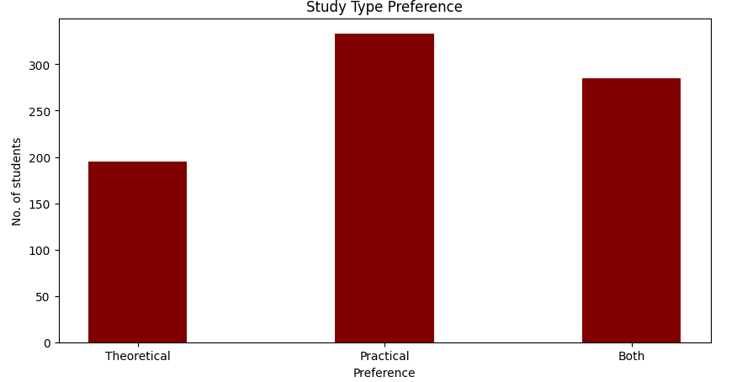

A mean confidence interval with a confidence of 95% was found to be

(0.11547470283012962, 0.22400869200381873)

On carrying out a hypothesis test on online education data where:

Theoretical was given a value of -1, Practical was given a value of 1 and both were given a value of 0.

NULL Hypothesis u= - 0.5 (mean of students interested in (majority of students interested in theoretical studies prefer online learning)).

Alternative Hypothesis u>-0.5 (students interested in practical prefer online learning).

A one-tail test is used with a confidence of 95%.

As a result, the Null Hypothesis was rejected and the alternative hypothesis was accepted.

Conclusion: On the contrary students interested in practical education are more interested in online education.

**5-Home Location:**  The following pie chart shows that the majority of students involved in online education are in the urban region:

Conclusion: Facilities (such as stable internet

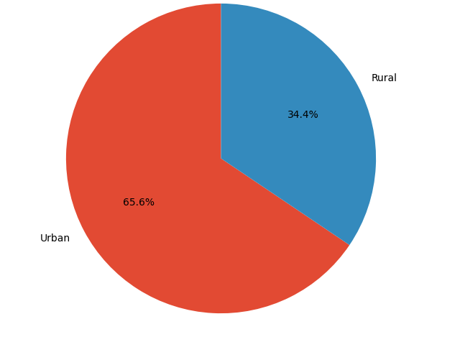connection)in the urban region make

Online education is more familiar there.

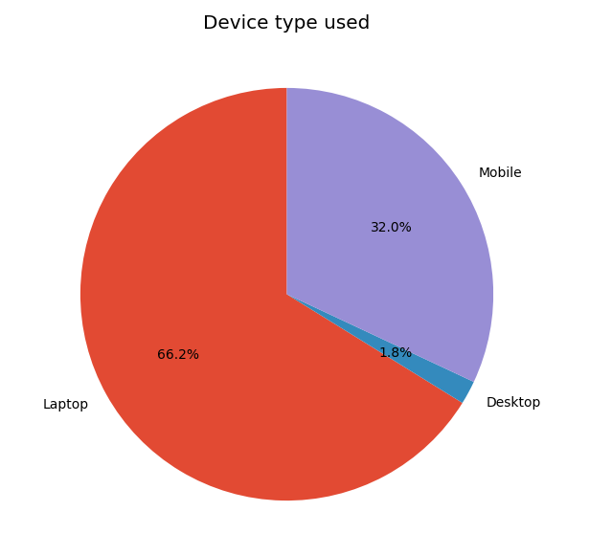**6-Device Type used:** The following pie chart shows the statistics for device types used by students in online education.

Conclusion: Online education doesn’t necessarily need a

PC or a laptop although it’s the most familiar device

among students.

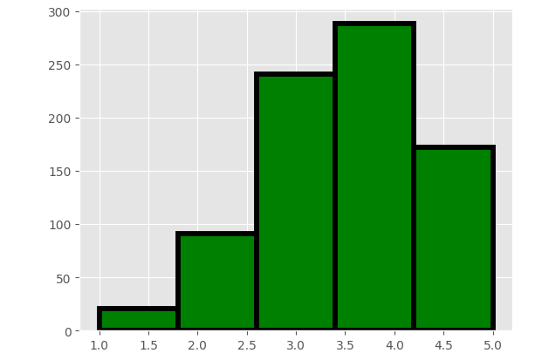**7-Internet Facility:** on a scale from 0 to 5 the internet facility of students involved in online education in the sample was measured and the following results were obtained.

Confidence for the mean with a confidence level of 95% was obtained which is:

(3.543561043472728, 3.683991232050027)

Conclusion: Internet Facilities are above average in the case of online education.

**8-Students’ Satisfaction Level:**

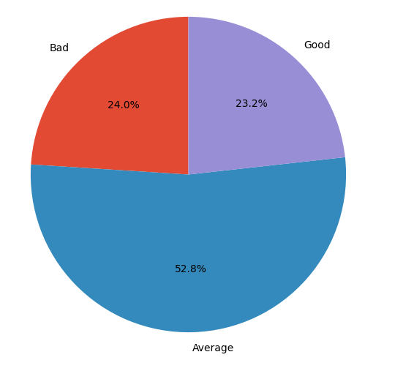Students’ satisfaction level with online education was measured in the sample (Bad- Average- Good) with the following results

Bad was given a value of 0, average was given a value

Of 1 and good was given a value of 2.

On calculating the confidence interval of the

Mean with a confidence level of 95%

It was found to be:

(0.9452815672403199, 1.039958285158204)

Conclusion: In general Students’ satisfaction level with online education is average.

**Conclusions**

1. The dependency of final grades on the study time in hours decreases on resorting to online education.
2. the mean of grades in the case of online education is higher with data more clustered around the mean.
3. The average of study hours in the case of online education is not the same as in the case of traditional education.
4. On the contrary students interested in practical education are more interested in online education.
5. Facilities (such as stable internet connection)in the urban region make Online education more familiar there
6. Online education doesn’t necessarily need a Desktop or a Laptop although Laptops are the most familiar device among students.
7. Internet Facilities are above average in the case of online education.
8. In general Students’ satisfaction level with online education is average.